|  |  |
| --- | --- |
| sait_icon_wordmark_colour.png | **CPRG 250**  **Assignment 2 Modules 4 Part 5-6, Module 5** |

**Instructions:**

* CREATE the SQL and SQL\*PLUS commands to answer the following questions using the Walnut Grove Bank (WGB) database as found in the Course Content-> Course Resources->Databases section of D2L. **Don’t forget to CLEAR COLUMNS and CLEAR BREAKS between the solution for each question.**
* Submit 2 files: a script file (assignment\_2.sql) and a spool file (assignment\_2.txt)
* Remember to set echo on, linesize and pagesize at the beginning of the script file
* Note: your output must match the mentioned output in terms of column headings, sorting of the records and the case (upper, lower…)

1. Create a customer list and categorize their accounts based on their account balances

|  |  |
| --- | --- |
| Balance | Category |
| 0 | Zero balance |
| 1-1000 | Low Balance in ***account\_description*** |
| 1001-5000 | Intermediate Balance in ***account\_description*** |
| > 5000 | High Balance in ***account\_description*** |

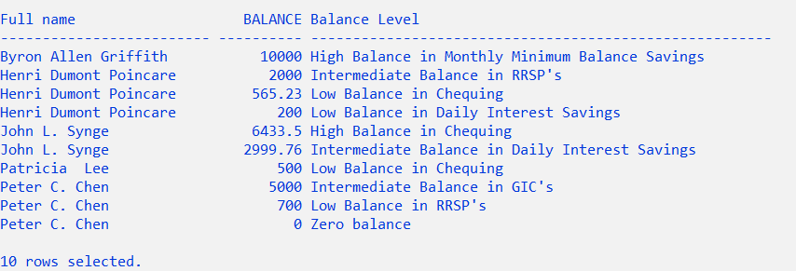

1. List the name of the customer, phone number (be careful for the format), account number, account type and balance for individual(s) who have the **largest account balance** for each account type. Solve using standard non-correlated, multi-column, multi-row subquery. Sort by account type and then name.

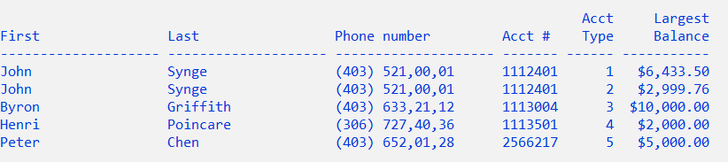

1. Solve Question 2 using a correlated sub-query and using a traditional join. Link the inner and outer query using the account\_type.

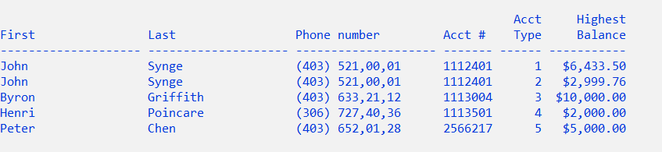

1. Show the top 2 customer information in terms of the number of active account types. Active account types are used to perform some transactions. Solve with JOIN… USING. Use Top-N analysis (Module 4 Part 6)

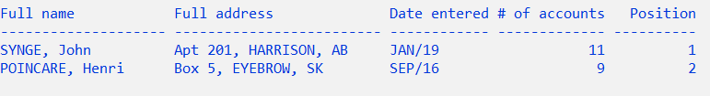

1. Use the Oracle rollup enhanced aggregation feature to show the names of the customers and for each customer, show the total of transaction amounts, the transaction dates and transaction amount itself. Those customers should not have address2. You can use a suitable aggregation levels to produce the following report.

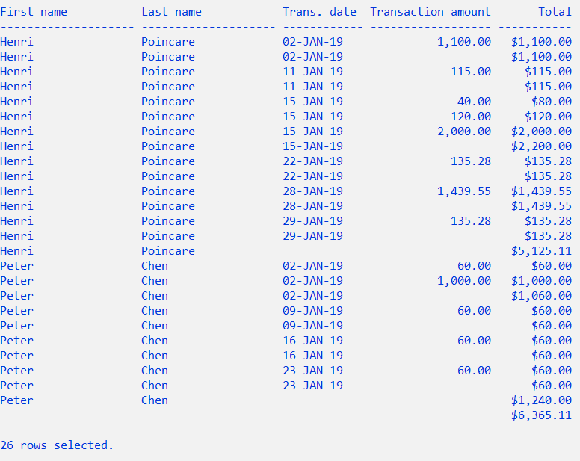

1. Create a report of all customers and their transactions as shown below. Note that the “Cust #” is a combination of the customer number and the account type. The transaction amount is negative if the transaction type is a “D” (Debit), so you can use CASE or DECODE to change the sign. Put the solution for this question in a separate script. Submit the script and spool file (report) to Brightspace.

